|  |  |
| --- | --- |
| **Name :-** | Aryan Dilipbhai Langhanoja |
| **Enroll No: -** | 92200133030 |

## Basics of AND gate and its application in car wiper control

* **Aim** :-

The aim of this experiment is to apply basic AND gate logic to control the on/off action of car wiper. The user will be able to drag and drop the two-input AND gate on the blank canvas and make input-output connections and verify the truth table

* 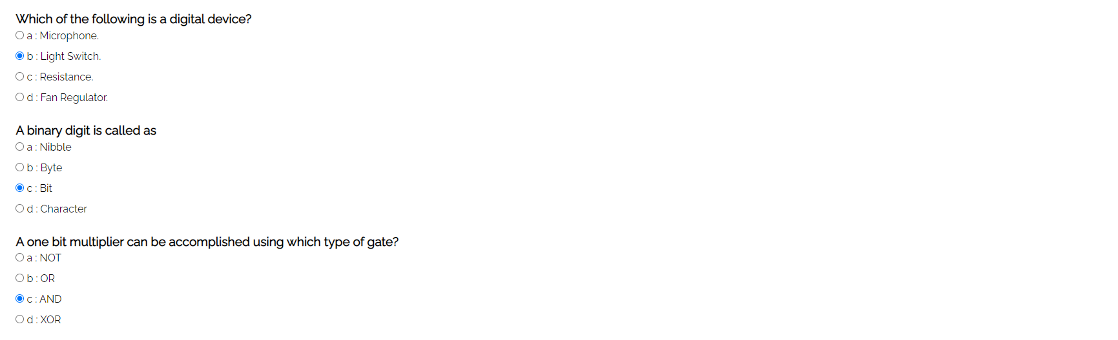**Pre-test :-**

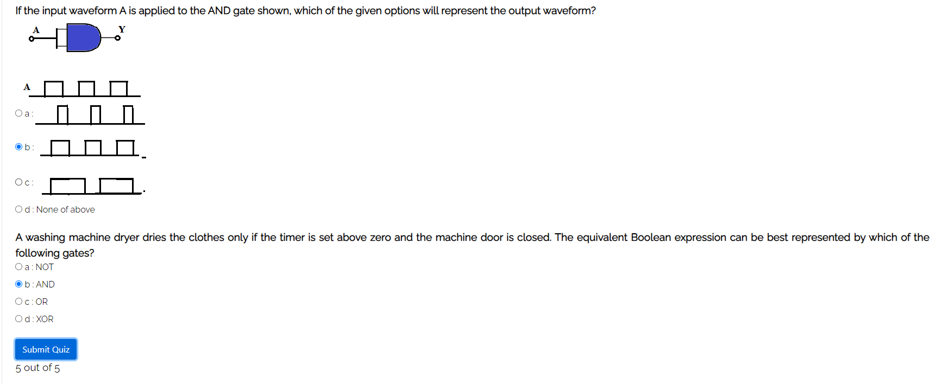

* **Simulation :-**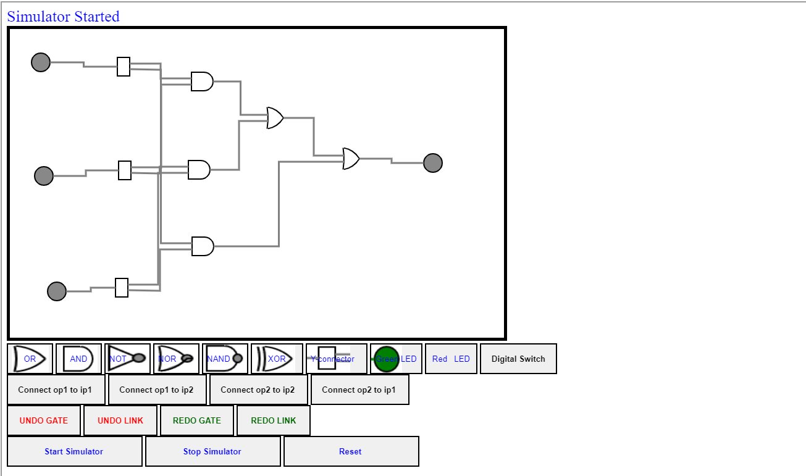
* **Post-test :-**

